Report: Maternal Age Outcomes
Data Analytics Capstone

In recent years women are delaying childbearing due to focus on career growth, education and financial stability. Many women indicate that they felt more prepared for motherhood when they reached their thirties and forties. Many assert that by delaying childrearing they're able to provide a more stable household for their children. Some women noted that it costs at least $100,000 to raise a child from birth to 18 at the bare minimum and they want to ensure that they have the financial foundation ahead of time. Many also indicate that mothers of advanced age are more compliant to prenatal care and are more educated. Some women noted that delaying childbearing until their careers are stable allows for flexibility to take time off as needed to focus on the needs of the child(ren). Conventional wisdom and the medical community indicates that pregnancy over the age of 35 is considered an geriatric pregnancy with high risk for mother and child.

Based on the 2019 National Vital Statistics Report: In the U.S, Over the last 40 yrs, there's been a marked increase in moms giving birth at age 35 and older. At the same time, the overall U.S. birth /fertility rate has decreased. Especially for teen mothers and mothers in their twenties, whose birth rates are at record lows. Notably there has been a rise in first time moms age being 35 & Up older, from 7.4% in 2000, to 10.8% in 2018. (National Center for Health Statistics, 2019). More recently, the average age at first birth is now 27 years of age, a record high for the United States of America. (National Center for Health Statistics, 2025). Is the trend of increased birth rates for older mothers still occurring since 2018? The data analysis used the CDC Wonder to query the United States health data for years 2018-2023 for infant infant mortality (death) rate by age (Table 1), gestational diabetes by age (Table 2) and birth rates by age ( Table 3) and fertility rates by age and race (2024) (Table 4). Note: dataset filtered by state as well except for the fertility dataset. Excluded mothers who were not born in the United States of America except for the fertility dataset.

This analysis is focused on how the age of the mother affects outcomes and will seek to answer the following questions:

- Are older mothers' birth rates truly increasing?
- Is infant mortality really higher for older mothers?
- Are older mothers actually experiencing higher rates of gestational diabetes?
- Do fertility rates decrease as women age?
- Are black or african american mothers more fertile as they age as compared to other races of mothers?

After the datasets were obtained from CDC Wonder, excel was used to manually check for blanks, formatting issues ( misspelling, capitalization, data type). The datasets were relatively clean, so CSV versions were made for upload to python using pandas and glob. Checked that the datasets were properly imported by calling for the dataframe keys. In order to keep the code clean and short all the datasets/dataframes were renamed to a simple one word name. After renaming the datasets head was called to ensure data renaming was processed properly. Checked for duplicate rows and missing values.

To answer the question, is infant mortality higher for older mothers? Using the delivery dataset: a variable was created to get the totals (sum) of births, deaths and calculate death per 1000 births. Then using matpotlib: created a bar and line graph to show deaths per 1000 for each age group ( Figure 1, Deaths Per 1,000 Births by Age of Mother), ( Figure 2, Trend of Deaths Per 1,000 Births by Age of Mother). After seeing the results, it looked important to see a visualization of birth volume alongside the death rate together and a bar/line combo plot was made. (Figure 3, Birth Volume and Death Rate by Age Group of Mother). I was curious to see if there was a correlation between education of the mother and the death (infant mortality) rate, so a variable was created along with a plot ( Figure 4, Births and Death Rate by Mother's Education). I wanted to see if the delivery method used had correlation to infant mortality aka death rate, I created another variable along with a bar/ line graph combo to see the overall trend using numpy ( Figure 5, Births and Infant Death Rate by Delivery Method). The results promoted me to see if there was a difference between the age groups. So another variable was made that excluded rows where the delivery method was unknown or not stated so that we can see clearly the difference between the 2 methods and created a line graph with seaborn (Figure 6, Infant Deaths per 1,000 Births by Age & Delivery Method). Also, created a map of the United States of America that shows births, deaths and death rate ( infant mortality) per state. (figure 11, Infant Mortality Across U.S. States (Deaths Per 1,000 Births).

In order to answer the question : Are older mothers' birth rates truly increasing? Using the births dataset. A variable was created to see if there was an increase in mothers 30 and older giving birth between 2018 and 2023 and a line graph was generated ( Figure 7, Birth Trends Over Time for Mothers Aged 30–44).

To answer the question, are older mothers actually experiencing higher rates of gestational diabetes? Using the diabetes dataset: duplicate rows were removed since they were filled with NaN. A bar graph was created to show if there is a relationship between age and diabetes (figure 8, Gestational Diabetes Rate by Mother’s Age Group).

In order to answer the question : Are black or african american mothers more fertile as they age as compared to other races of mothers? Using the fertility dataset. A variable was created to see which race by age group has the highest weighted fertility rate and a heat map was generated ( Figure 9, Fertility Rates by Age and Race (2024)).

In order to answer the question : Do fertility rates decrease as women age? Using the fertility dataset in excel and canva. A pivot table was created to see which age group has the highest fertility rate and a line graph was generated ( Figure 10, Fertility Rate).

Key Findings:

The data indicates that infant mortality (infant death rate) decreases as women age, with a notable spike at age 40-44. Birth rates are showing modest increases for moms 30 and up between 2018-2023 with a spike for 2021 (maybe related to COVID-19 quarantine). The data shows that mothers with c-sections had higher rates of infant mortality across all age groups as compared to mothers with virginal births with the rates decreasing as the mother age goes up. The data also shows mothers with a higher education had lower infant mortality rates. The data showed that the risk of developing gestational diabetes does increase as women age however there is a significant drop for women aged 45-49. The data showed that mothers of native Hawaiian or pacific islander had the highest fertility rates, with white mothers coming in next and as mothers age Asians had the next highest rates followed by black or african american mothers. The data also shows that mothers age 30-34 have the highest fertility rates with mothers aged 35-39 having higher fertility rates than mothers aged 20-24 and lastly mothers aged 40-44 have higher fertility rates than mothers aged 15-19.Overall the data shows the best outcomes for mothers 30-40 in particular mothers aged 30-34.

Recommendations and future considerations:

Based on the data mothers can consider with their doctors to opt out of c-section where possible, to decrease the risk of infant mortality. Potential older mothers can consulate with their doctors and nutritionist to manage insulin level before and during pregnancy.
Potential mothers may want to consider higher education, as the data suggest improved outcomes for mothers with higher education. Future considerations includes the
economic factors such as the mother’s disposable income for fertility treatments and the mothers access to advanced healthcare may provide a more complete picture. We may also want to consider looking at birth defects and genetic disorders of infants of older mothers as well.

Dataset Links:
CAPSTONE DATASET DAB JULY 2025
CSV Datasets:
- Infant Mortality by age delivery infant mortality .csv
- Gestational Diabetes by age Gestational Diabetes.csv
- Birth Rate by age Birth Rate By Age EDU.csv
- Fertility rates by age Fertility Rate.csv

Reference List

National Center for Health Statistics. (2019, March 23). Births: Final Data for 2019 (National Vital Statistics Reports; vol. 70, no. 2). National Vital Statistics Reports Volume 70, Number 2, March 23 Births: Final Data for 2019

National Center for Health Statistics. (2025, June 13). Trends in Mean Age of Mothers: United States, 2016–2023 (National Vital Statistics Reports; vol. 74, no. 9). National Vital Statistics Reports Volume 74, Number 9 June 13, 2025 Trends in Mean Age of Mothers: United States, 2016–2023.

Tables:

- Table 1: Infant Mortality by age delivery infant mortality .csv
- Table 2: Gestational Diabetes by age Gestational Diabetes.csv
- Table 3: Birth Rate by age Birth Rate By Age EDU.csv
- Table 4: Fertility rates by age Fertility Rate.csv

Figures:

Figure 1:

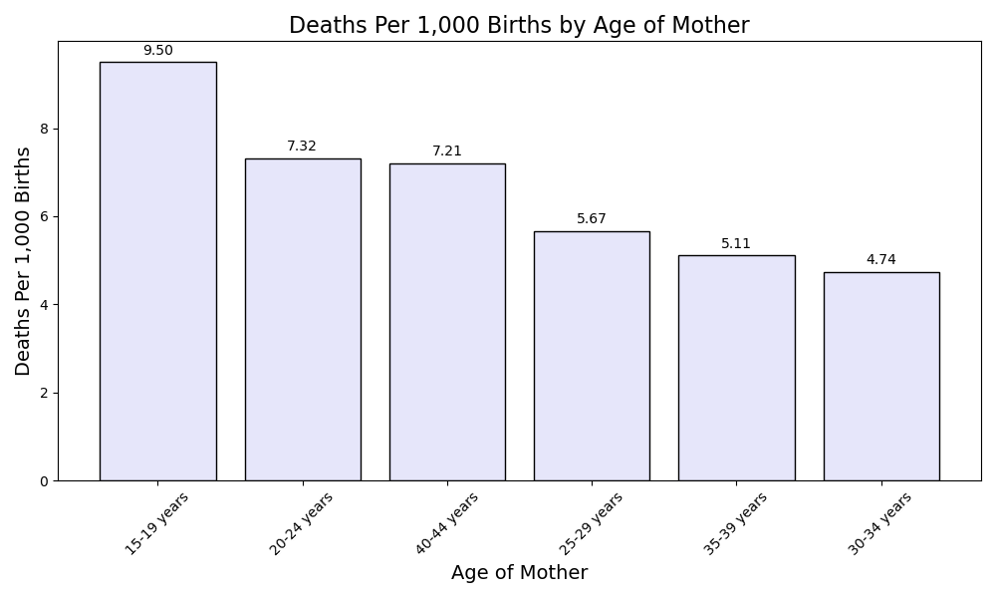

Figure 2:
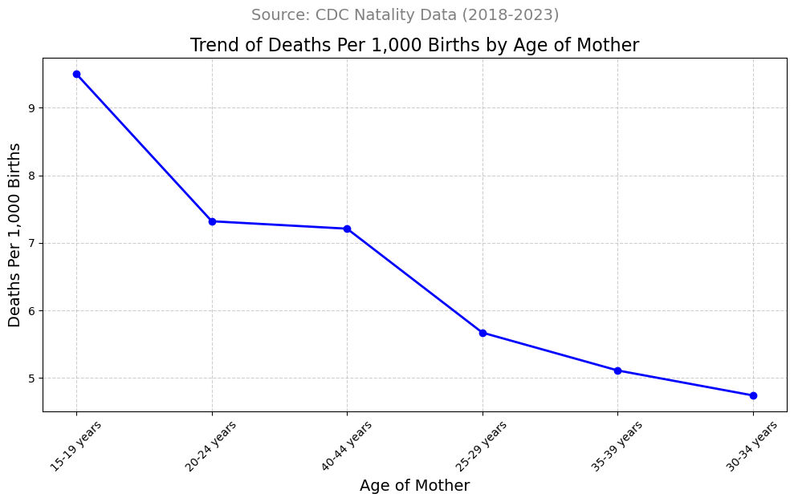
Figure 3: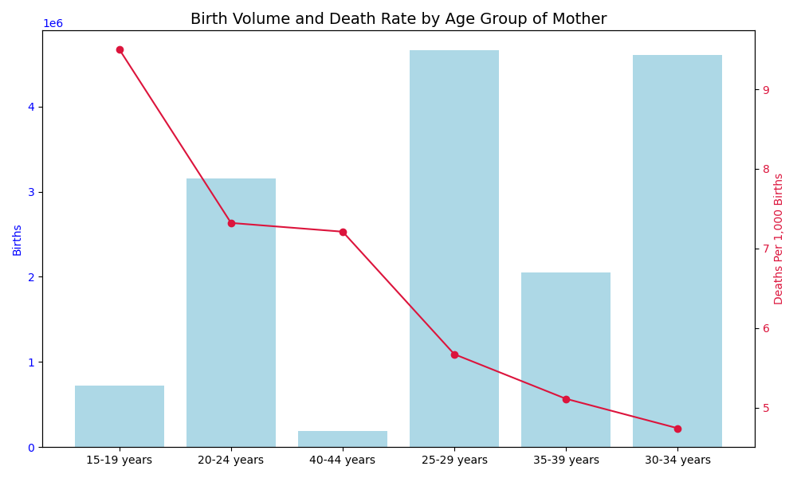
Figure 4: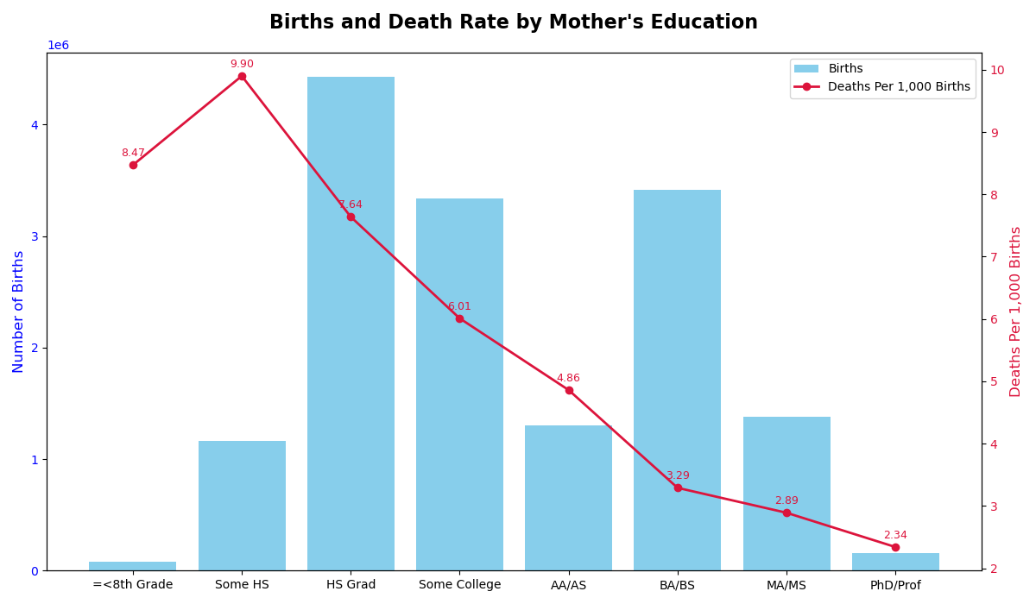
Figure 5: 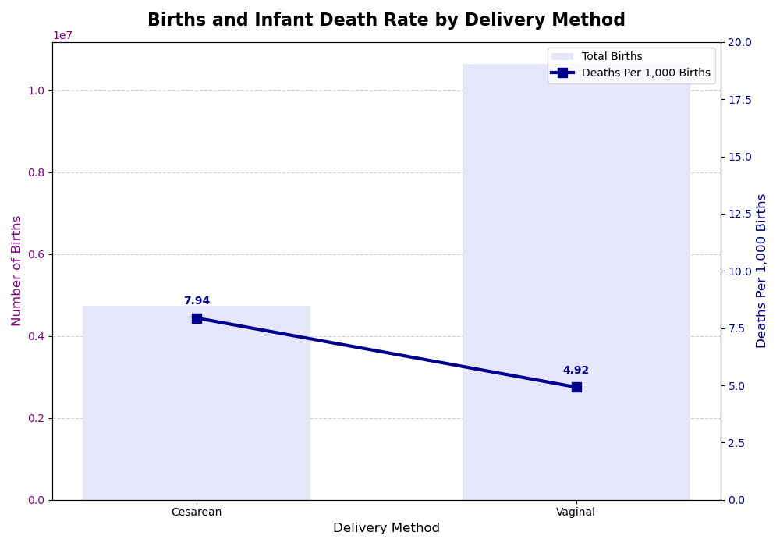
Figure 6: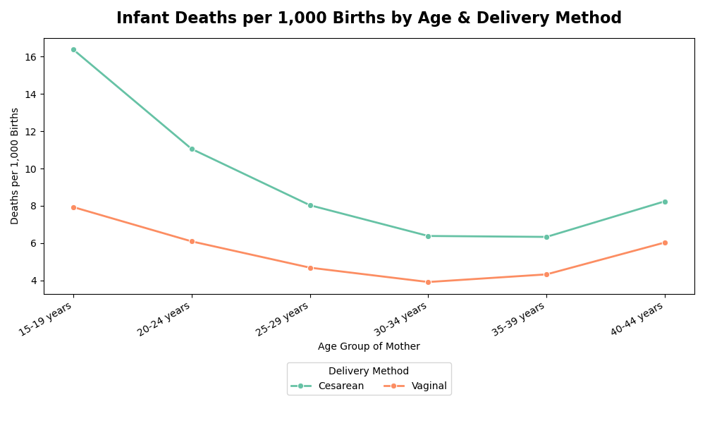
Figure 7: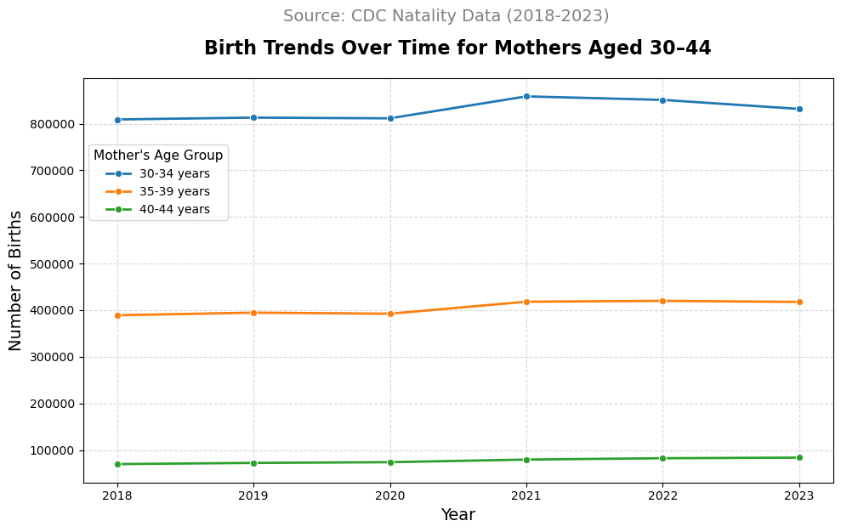
Figure 8: 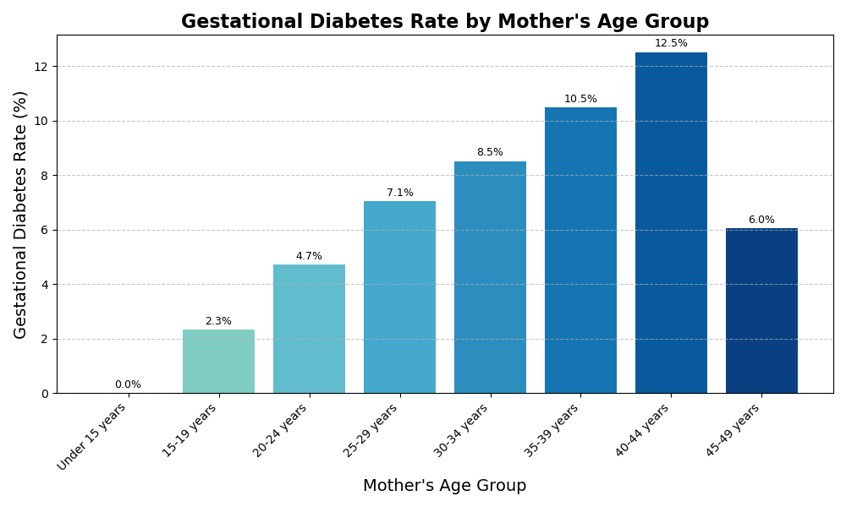
Figure 9: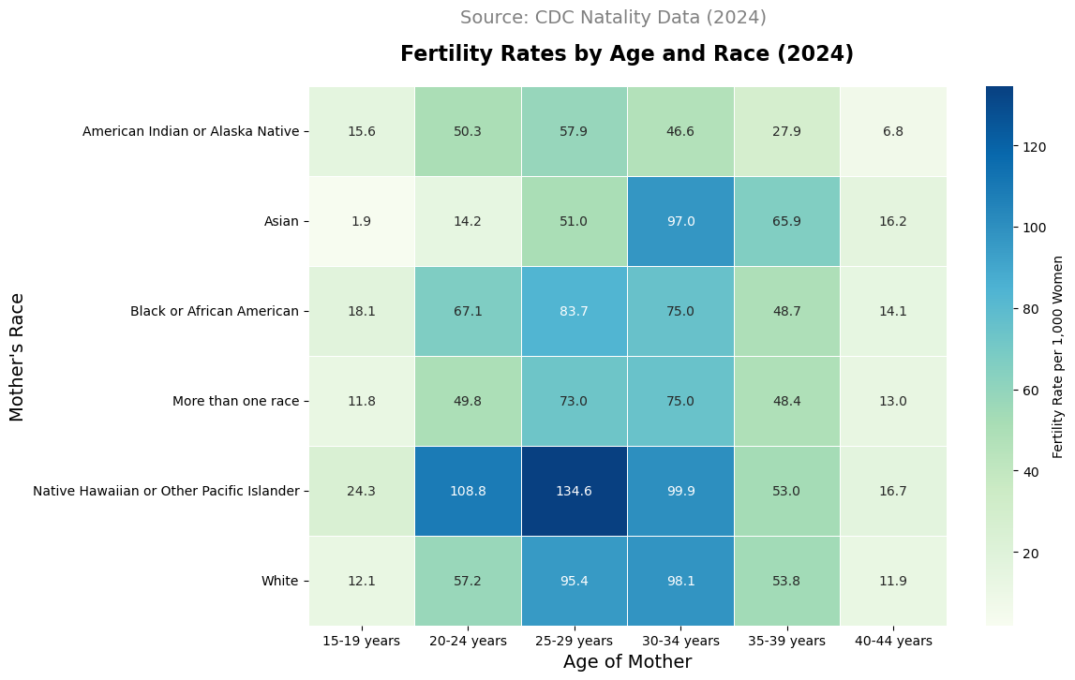
Figure 10: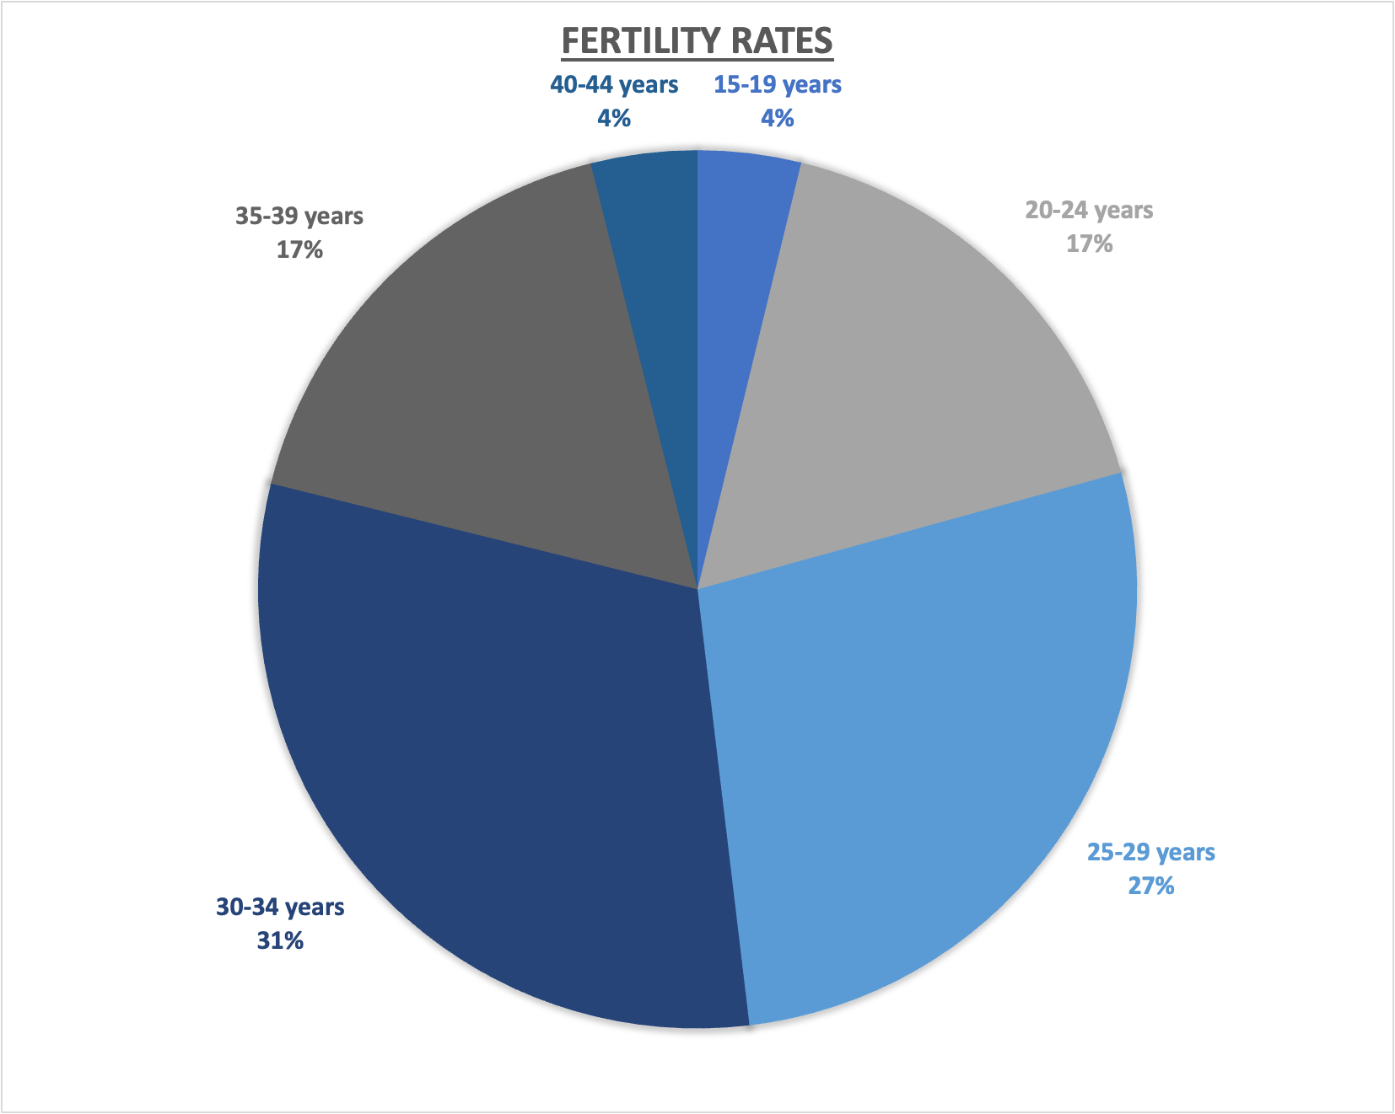

Figure 11:Infant Mortality Across U.S. States (Deaths Per 1,000 Births)
